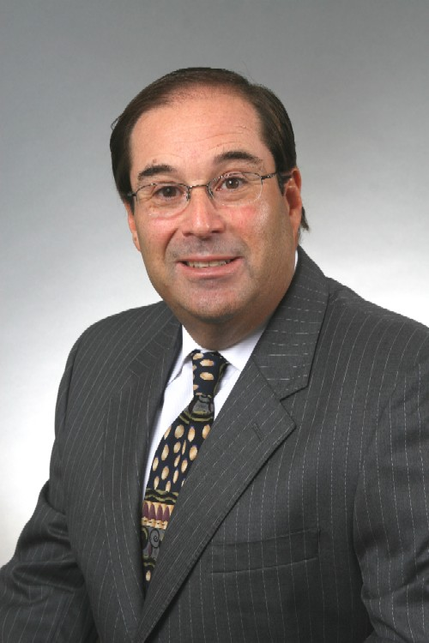 |  | Steven R. Rosenbaum, C.P.A.  Managing Member
Profile  A Certified Public Accountant with over 30 years of diversified experience.  Over my career, I have had experience in the litigation support arena, including expert witness testimony, serving as, and assisting court appointed fiduciaries, and exposure to some of South Florida’s largest frauds over the last 15 years.  I will support my clients through all their financial needs, from individual tax filings to corporate restructuring or financial consulting.  Contact  PHONE:  954-744-8440  WEBSITE:  https://theflacpa.com/  EMAIL:  srosenbaum@theflacpa.com  Skills  - Forensic Accounting  - Insolvency Accounting  - Income Tax Preparation  - Consulting |  | EDUCATION  Farleigh Dickinson University  Bachelor of Science in Accounting, 1978, Magna Cum Laude  WORK EXPERIENCE  Rosenbaum Sobel Weinrub LLC – Managing Member & Co-Founder  2011-Present  Dawson, Rosenbaum & Sobel, P.A - Partner  1992–2011  Richard A. Eisner & Company (Now EisnerAmber) – Manager, Small Business Services  1986–1991  Various Medium-Sized C.P.A Firms - Senior Accountant  1978–1986  Certifications and Memberships  Certified Public Accountant -- Florida 1991, (New York 1982 currently inactive)  Member of the American and Florida Institutes of Certified Public Accountants  Certified Fraud Examiner, 1995  Certified Specialist in Estate Planning, 1999 (Inactive)  Certified in Financial Forensics, a designation issued by American Institute of Certified Public Accountants, 2008

